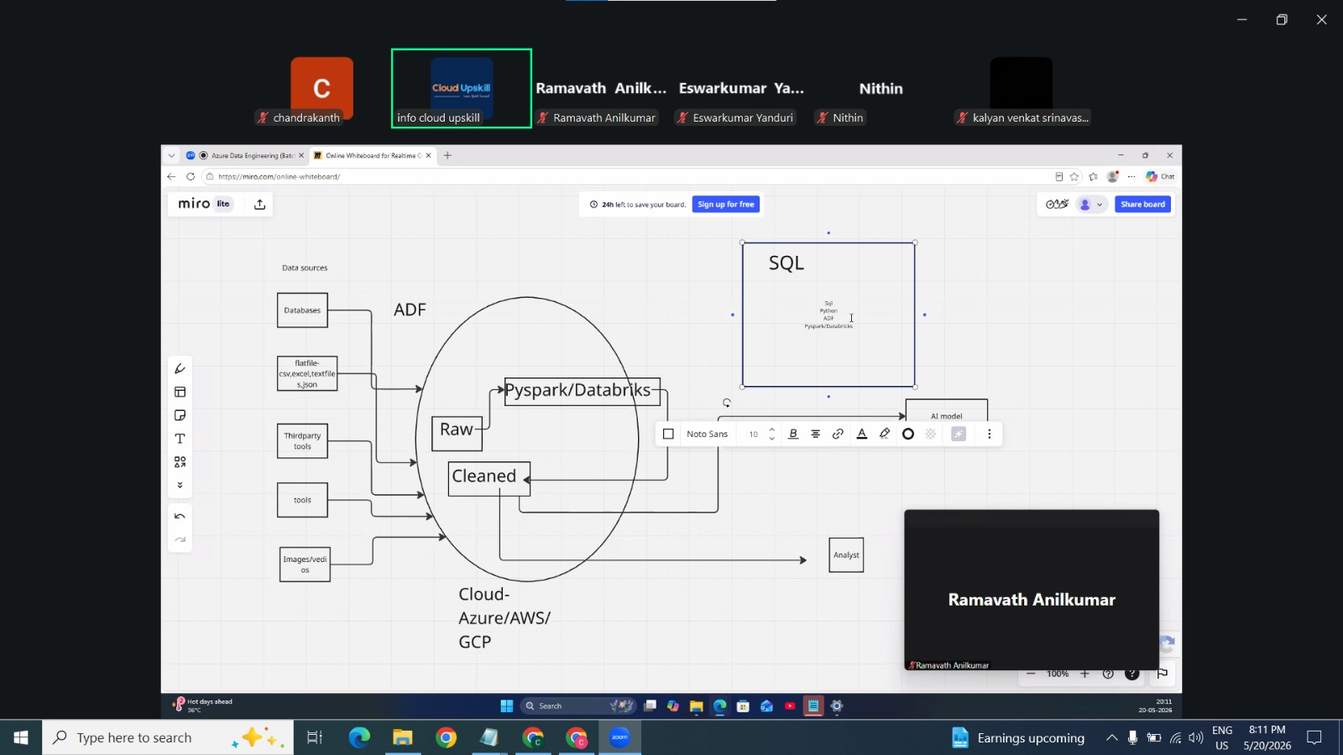

What is data and what is data engineering?

Data is used for analyzing the business, whether it should get enhanced or making limited based upon the market demand. And also used for feeding and training the AI model.

Data engineer collects the RAW data in different formats (from databases, log files, flat files (csv, excel, text file, json), third-party tools, SAP tools, images, videos etc.…) with help of all these RAW data we are storing it into CLOUD by using azure data factory.
And making it clean and making it into organized format by using pyspark/databricks.

Pyspark is open source model and databricks is cloud model. For learning the ADE the very basics are SQL & PYTHON.

